

**Faculty of engineering - Shoubra**

**Benha University**

**Research Project**

in fulfillment of the requirements of

|  |  |
| --- | --- |
| **Department** | **Engineering Mathematics and Physics** |
| **Division** | **-----------------** |
| **Academic Year** | **2019-2020 Preparatory** |
| **Course name** | **Computer** |
| **Course code** | **ECE001** |

**Title: -**

**Artificial Intelligence**

By:

|  |  |  |  |
| --- | --- | --- | --- |
|  | Name | Edu mail | B.N |
| 1 | Ahmed Henedy Ibrahim Elbllat | Ahmed195154@feng.bu.edu.ed | 150 |

**Approved by:**

|  |  |
| --- | --- |
| Examiners committee | Signature |
| Dr.Ahmed Bayoumi |  |
| Dr. Shady Elmashad |  |
| Dr . Abdelhamid Attaby |  |

**Github link:-**

**Application brief:**

**(Artificial Intelligence)**

-Ability of a digital computer or computer controlled robot to perform tasks commonly associated with intelligent beings.

-The term "artificial intelligence" is often used to describe machines (or computers) that mimic "cognitive" functions that humans associate with the [human mind](https://en.wikipedia.org/wiki/Human_mind), such as "learning" and "problem solving"

**Computer Ingeniery:**

We need two things for artificial intelligence to succeed: intelligence and an artefact. The Computer was the choice artefact. The first digital electronic computer was autonomously and almost simultaneously invented by scientists in three countries in World War II. The electromechanical heath robinson was the first operating computer, Built in 1940 for a single purpose by Alan Turing 's team: to decipher German Messages. In 1943, the same group produced a powerful general-purpose computer, the Colossus On vacuum pipes. The Z-3, Konrad Zuse's 1941 invention in Germany, was the first operational programmable computer. Zuse invented floating point numbers, as well as First programming language of high standard, Plankalkül. The first e-computer, the ABC, John Atanasoff and his student Clifford Berry were placed in between 1940-1942 At University of Iowa. The work at Atanasoff has earned little funding or recognition; The ENIAC, established by the University of Pennsylvania as part of a classified military project By a team including John Mauchly and John Eckert, the most influential of which proved Precursor to modern computers. Growing generation of computer hardware has since taken pace up And power, and the price decrease. Every 18 months or so the score doubled until about 2005 When problems with power dissipation led manufacturers to start multiplying the number of CPU cores, rather than speed of the clock. Present plans are for potential power gains It is emerging from huge parallelism— a peculiar convergence with the brain's properties. AI 's research has pioneered many innovations that have returned to conventional computer science, including Time sharing, interactive interpreters, Windows and Mice personal computers, fast development environments, linked list data sort, automated storage and key management Symbolic, functional, declarative, and object oriented programming principles.

**The birth of artificial intelligence** **(1956):**

Princeton was home to John McCarthy, another prominent figure in AI. Having got his Dr. McCarthy moved to Stanford in 1951 and served as a teacher for 2 years, then to Dartmouth College, which was to become the sector's official birthplace. McCarthy told Minsky, to assist get him Shannon and Nathaniel Rochester Together U.S. researchers engaged within the theory of automata, neural networks and intelligence studies. Within the summer of 1956 they held a two month workshop at Dartmouth. The Proposal reads: We decide to perform a 2 month, 10 man AI study starting out at Dartmouth College in Hanover, New Hampshire during the summer of 1956. The study shall proceed on the idea of the idea that each one aspects of in theory , learning or the other feature of intelligence are often so accurately described that a machine are often designed to simulate it. An effort is being made to seek out How machines can use language, shape abstractions and definitions, solve sorts of problems Issues that are reserved for humans now, and improve themselves. We expect it is a significant progress in one or more of those problems could also be made if caution is taken for the summer selected group of scientists will work together thereon.

**AI evolves into an enterprise (1980–present):**

At the Digital Equipment the first successful commercial expert system, R1, began operation Firma (McDermott, 1982). The program has helped to configure new computer orders Systems; the Company saved an additional $40 million a year by 1986. By 1988, The DEC AI Group had deployed 40 expert systems, with more on the way. DuPont numbered 100 in Use and development of 500, saving an estimated $10 million per annum. Close to any major U.S.

[**Applications of artificial intelligence**](https://en.wikipedia.org/wiki/Applications_of_artificial_intelligence)**:**

**1-Healthcare**

As an example, AI is being applied to the high-cost problem of dosage issues where findings suggested that AI could save $16 billion. In 2016, a groundbreaking study in California found that a mathematical formula developed with the help of AI correctly determined the accurate dose of immunosuppressant drugs to give to organ patients.

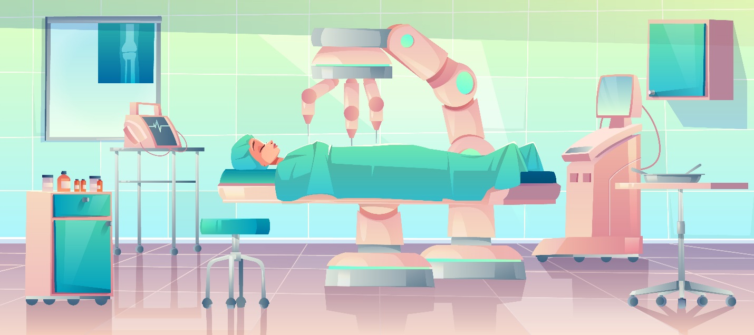

**2-** **Agriculture**

In agriculture new AI advancements show improvements in gaining yield and to increase the research and development of growing crops. New artificial intelligence now predicts the time it takes for a crop like a tomato to be ripe and ready for picking thus increasing efficiency of farming.

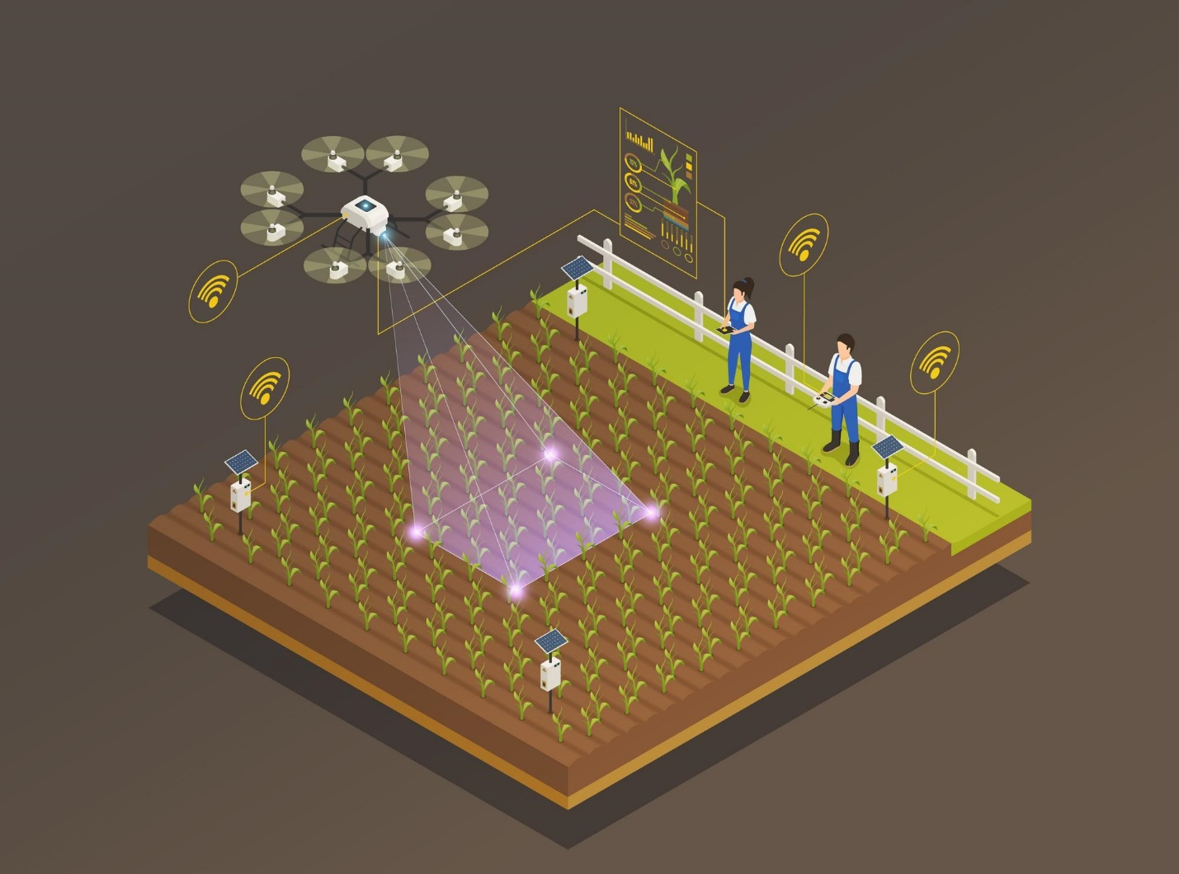

**Screenshots:**

**-Website**

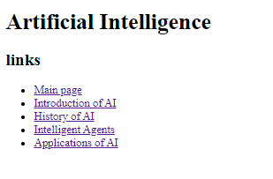

-Source code

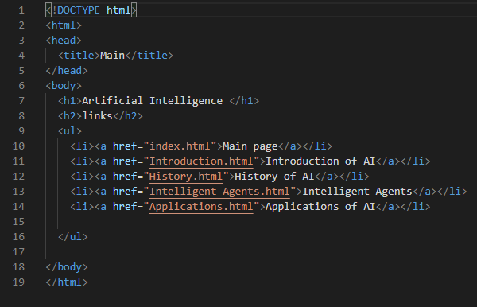

**-Website** 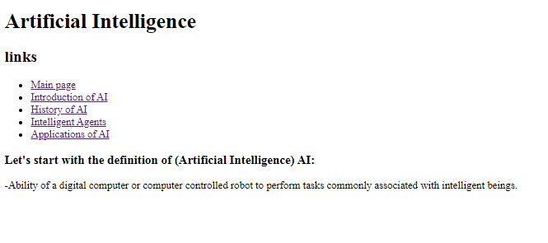

**-Source code**

